How to get your Account SID and Auth Token for our Python Program

Open Browser and key in this URL

twilio.com

Login to your Twilio Account.

You will see Twilio’s landing page. Click on Console

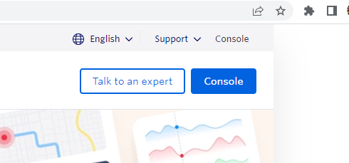

And you will see this page

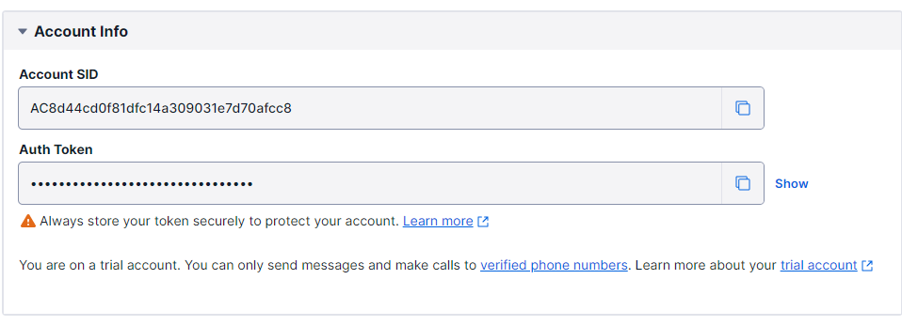

Use the copy icon to copy them to a text file which you can retrieve this coming Sun.

You need them for the Alert Messaging program.